**DOMAIN LAYER**

**Aim:**

To implement the domain layer of online exam registration system.

**Resources used:**

Equipment:

* UML tool
* Programming languages (Html, Javascript)

Consumables:

* Printers

**FORMS:**

**LOGIN PAGE:**

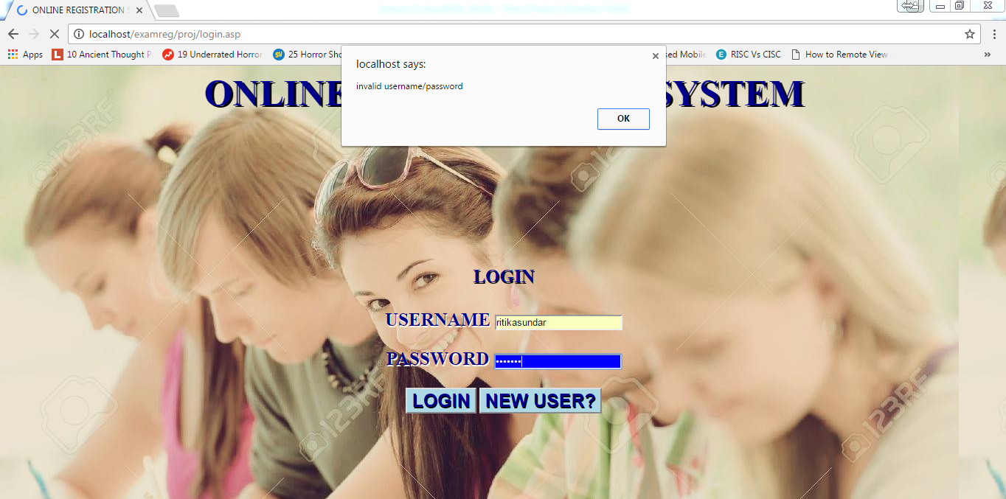

**HOME PAGE:**

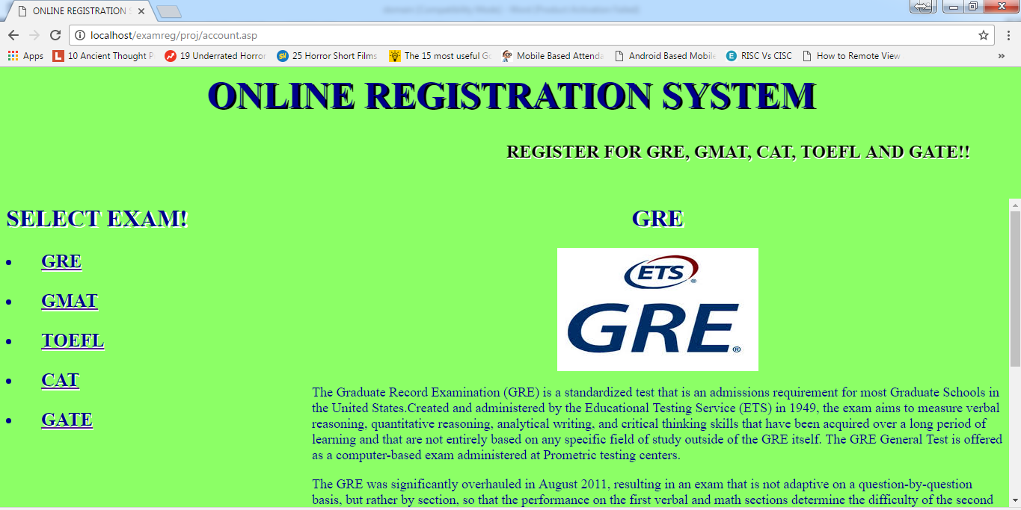

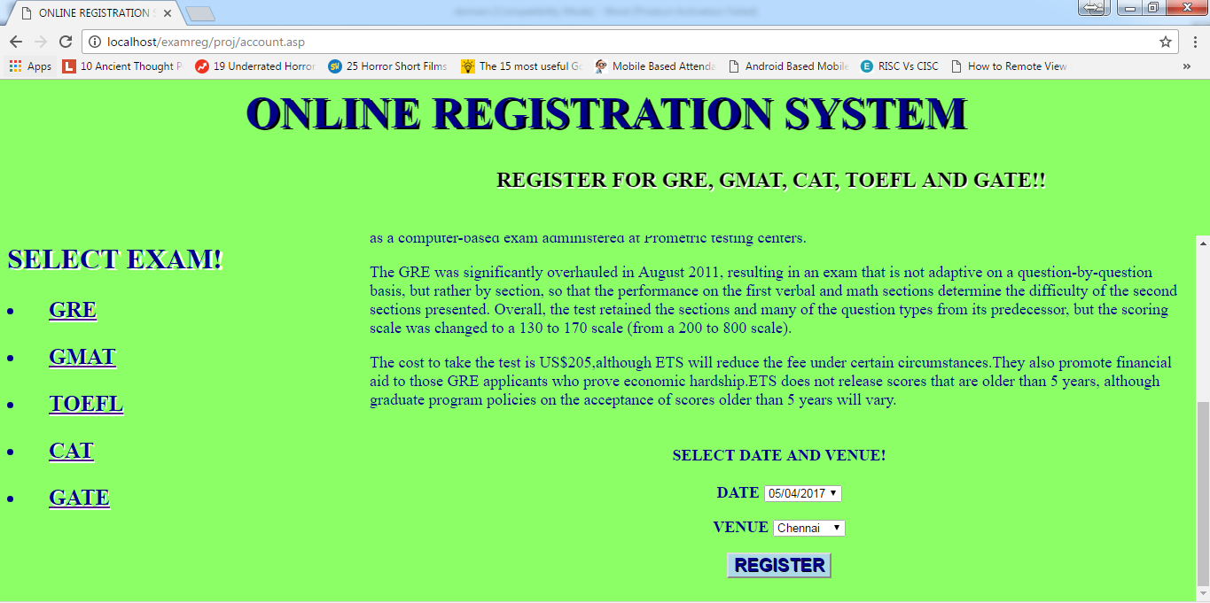

**EXAM REGISTRATION:**

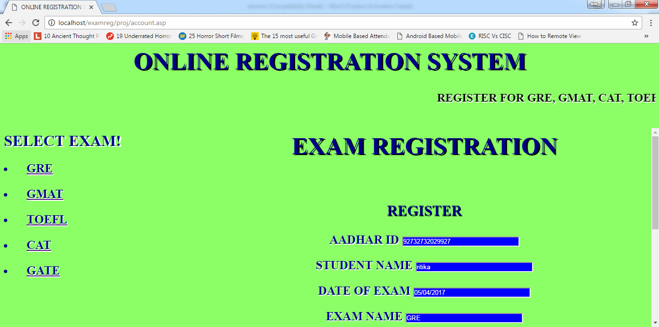

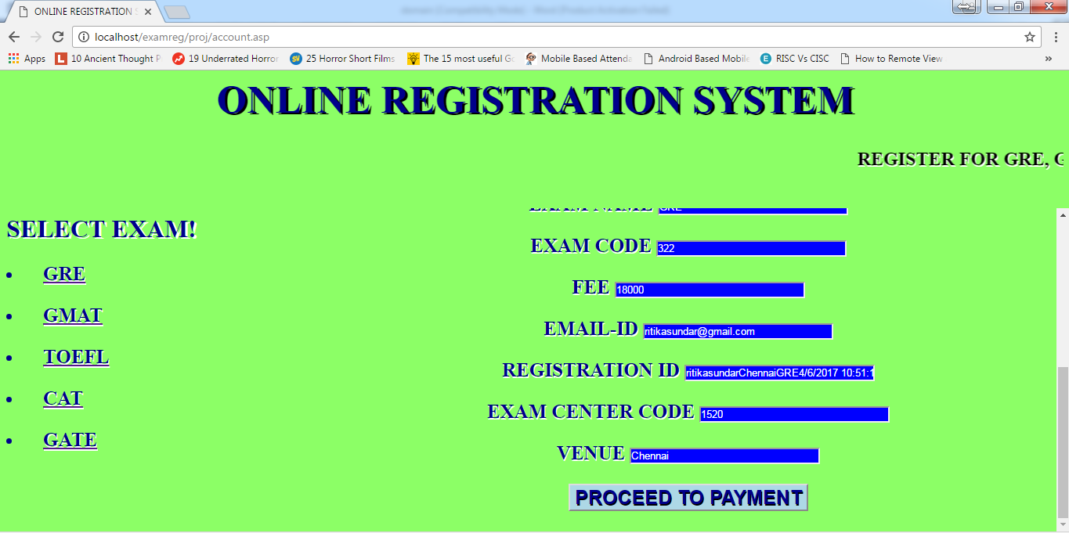

**PAYMENT:**

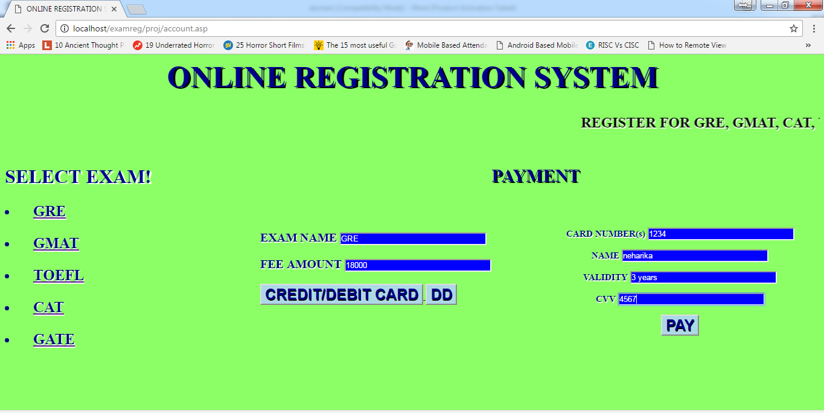

**PAYMENT ACKNOWLEDGEMENT:**

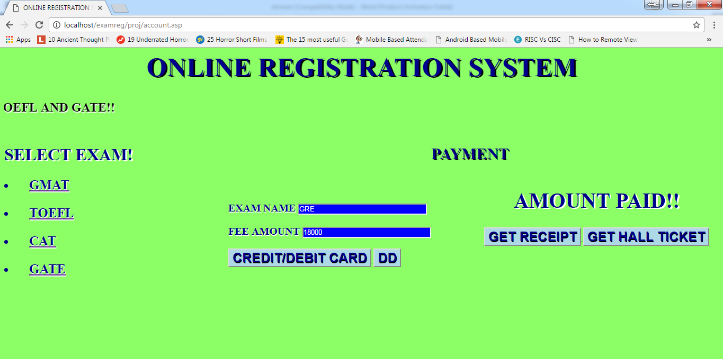

**RECEIPT:**

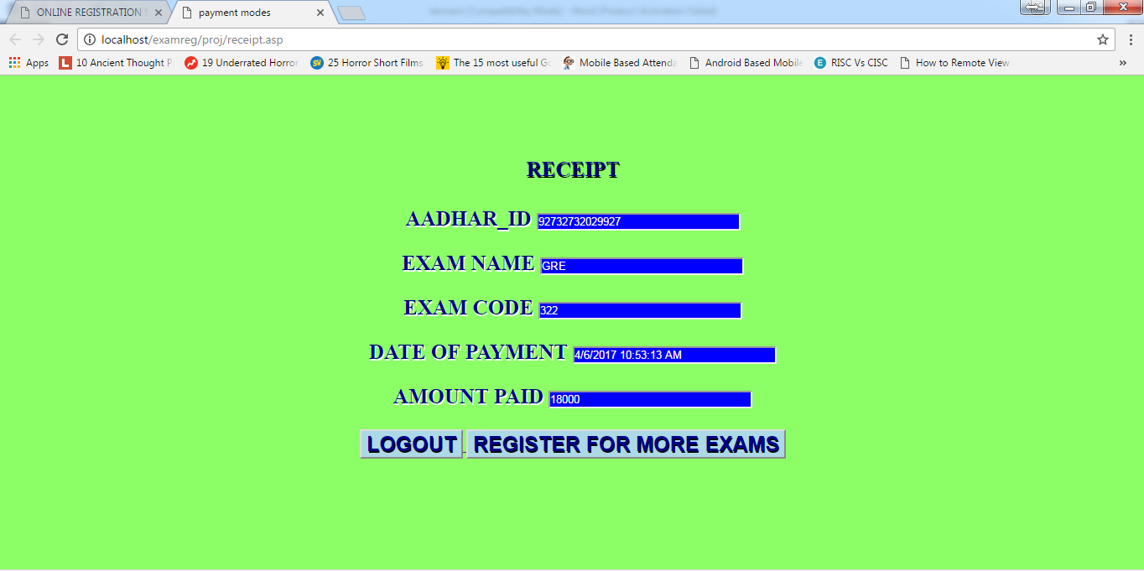

**HALL TICKET:**

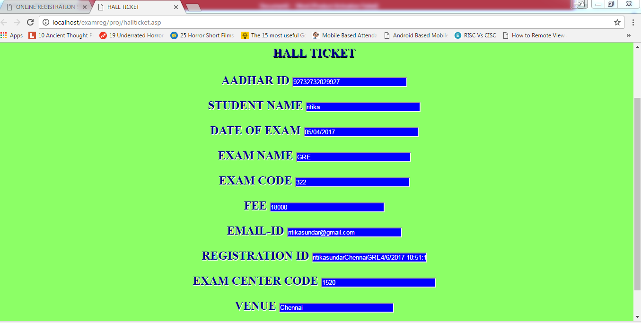

**Result:**

Thus the domain objects layers for online exam registration system have been implemented and verified.